1.
Draw a labeled diagram of a Cat6 Ethernet cable, showing the color order of wires in the T568B standard and labeling the RJ-45 connector pins.
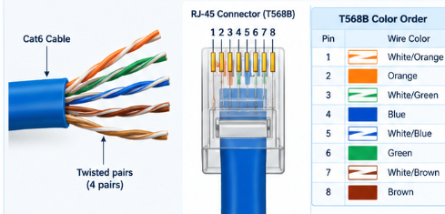
2.
List three types of network cables (such as Cat5e, Cat6, and fiber optic) and for each, mention one real-world app or device (like a WiFi router, Zomato POS terminal, or IPL streaming server) where it would be used, explaining why.
Cable type | Real-world application | Why it is used
Cat5e | Wi-Fi router connected to a desktop PC | Supports Gigabit Ethernet for normal home and office networking.
Cat6 | Restaurant POS terminal connected to a network switch | Provides a reliable wired connection for payment and order processing.
Fiber optic | Data-center servers delivering IPL live streams | Supports high bandwidth over long distances and resists electromagnetic interference.

3.
Watch a YouTube video showing how to crimp an RJ-45 connector onto a network cable, then write down the step-by-step process in your own words and mention two common mistakes to avoid.
- Gather a Cat5e/Cat6 cable, RJ-45 plugs, a wire stripper, crimping tool and cable tester.
- Strip about 2–3 cm of the outer jacket carefully, without damaging the inner wires.
- Untwist and straighten the eight wires.
- Arrange them in T568B order: white/orange, orange, white/green, blue, white/blue, green, white/brown, brown.
- Trim the wires evenly and insert them into the connector, keeping all wires in the correct order.
- Push the cable far enough that all wires reach the connector tips and the outer jacket sits beneath the strain-relief tab.
- Crimp firmly using the crimping tool.
- Repeat at the other end using T568B again, then test the cable.
Two common mistakes to avoid:
- Wrong wire order: Even one misplaced wire can cause a connection failure.
- Poor insertion: If the wires do not reach the contacts or the outer jacket is not secured, the connection may be unreliable.
4.
Given the following scenario: You are setting up a gaming zone for an IPL screening event and need to connect multiple screens and consoles. Choose the appropriate cable and connector types for high-speed, reliable connections, and explain your choices.
I would choose Cat6 Ethernet cables with RJ-45 connectors to connect the gaming consoles, PCs and network switch.
- Cat6 cable: Provides stable, high-speed Ethernet and is suitable for low-latency gaming and local streaming.
- RJ-45 connector: Standard connector for copper Ethernet ports on PCs, consoles, routers and switches.
- Network switch: Allows several wired devices to communicate on the LAN simultaneously.
- Fiber optic (optional): Useful for long backbone links between buildings or network cabinets when high bandwidth and distance are required.

5.
Find and share a photo (from your home, college, or online) of any network cable or connector in use (such as behind a WiFi router or at a café's POS counter), and describe what type it is and what devices it connects.<br><br><em><strong>Hint:</strong> Look for blue or yellow cables with clear plastic ends (RJ-45) or thin round cables for fiber optics.</em>
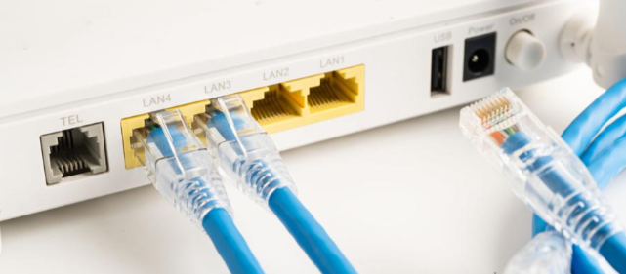
The photo shows an Ethernet cable with an RJ-45 connector plugged into a LAN port on a Wi-Fi router. The cable can connect the router to a desktop computer, laptop, smart TV or network switch. This wired connection carries network data and generally provides a more stable connection than Wi-Fi.

